1. How to setup git on Windows environment:

<https://msysgit.github.io>

1. Then setup gitbash client on system.
2. Open gitbash, this will show you a command window console to run command.
3. Command – to do some configuration like – how to set user name to track who made changes.

git config –global user.name ”Tarun Seetha”

$ git config --global user.email "tarun.seetha@gmail.com"

Without setting above two commands we will not be able to commit any changes via git commit command. I got following error when I was trying to run git commit without these configurations.

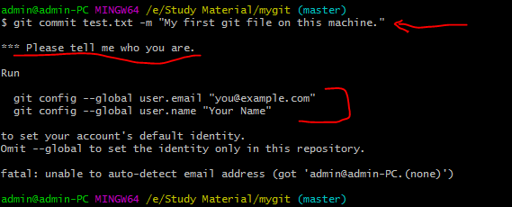

1. Command – To show list of all configurations

git config –list

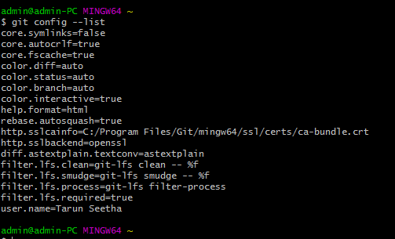

1. Command – To take git help run command “git help”. Like to take help of git add command we can type “git help add”
2. Command to create an empty git repository on our local machine. Run command “git init”

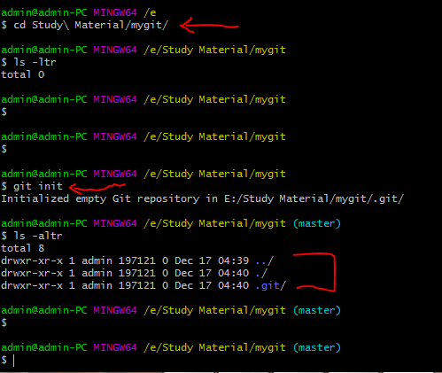

1. Command to know the status of git directoy like what are the files are newly added and not yet committed etc. “git status”

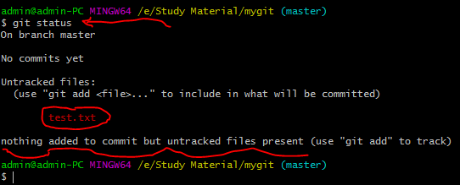

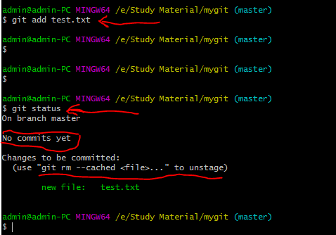

1. Commit command:

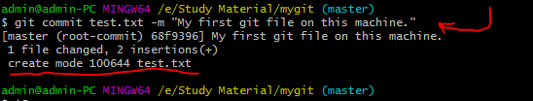

1. To see the differences made to all the files of a directory in a glance, use command “git diff”. But to see the differences / changes made to a particular file, pass the file name as last argument to git diff command.

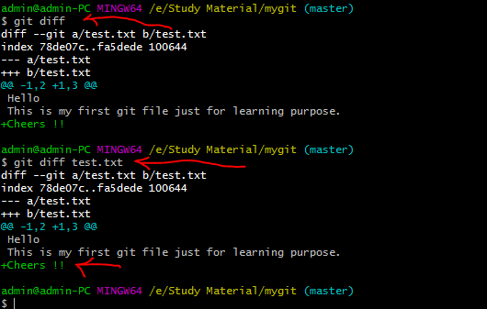

**Note:**

1. I can run “git add” command again to stash the changes which I made and very soon going to commit. So if I add “git add” again then there will not be any issue and I then compare the o/p of “git diff” and “git diff –cached”.

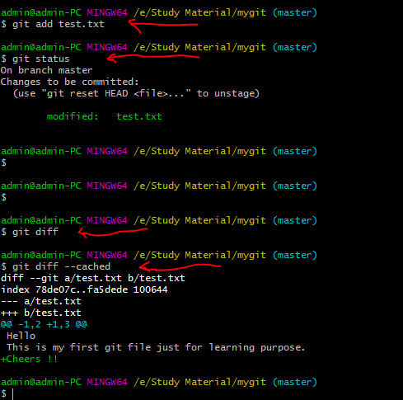

1. Use “git rm” command to delete any file.
2. To see the history of all commits in chronological order, use git log command.
3. Example of “git delete” and “git log” command.

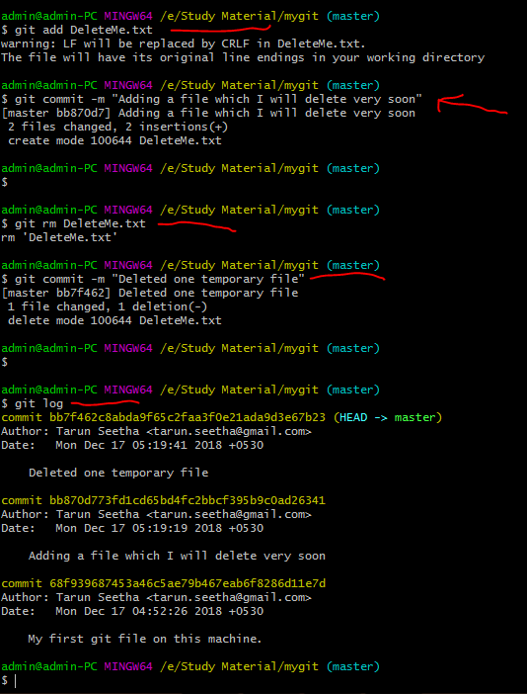

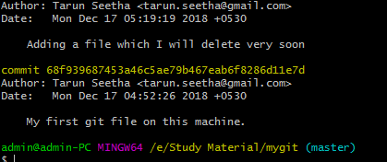

To show all the logs in pretty format, let say in one line only. Use following command:

git log –pretty=oneline

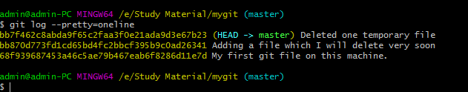

**To use some format in pretty command to view logs in a customized format.**

git log –pretty=format:”%h : %an : %ar : %s”

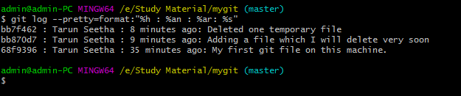

**To see the logs of only last 2 commits.**

git log -p -2

To see all the logs in last one week

git log --since=1.weeks

**To see logs for a specific author**

Git log –author=”Tarun Seetha”

**To see logs before a specific date**

Git log –before=”2018-12-09”

**To see logs after a specific date**

Git log –since=”2018-09-12”

## References:

1. <https://www.youtube.com/watch?v=r63f51ce84A>